CIVILIZATION: The Expansion Project
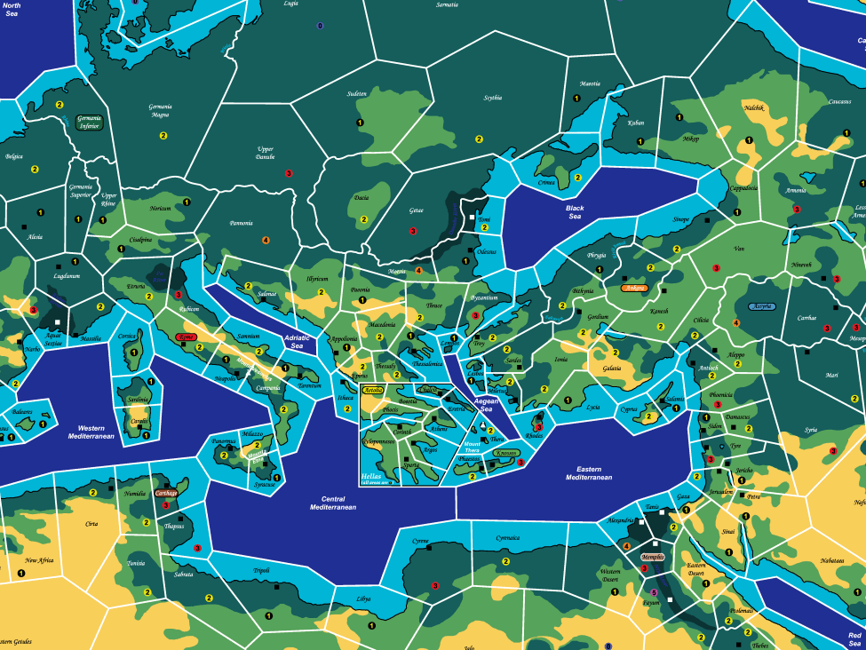

Optional Rulebook
Version 2.10
(2008-01-13)

Overview
YET TO BE WRITTEN

I. Playing A Shorter Game
1.1 It is often difficult to dedicate the ten to eighteen hours needed to play a full game. While the option of a predetermined time limit exists, using that option severely limits the opportunity to experience the endgame with the more expensive civilization cards in play. This section provide an alternative to begin play with all civilizations well on their way to glory. Please note that these rules can be combined with a predetermined time limit to play only the middle of the game.
1.2 Depending on the amount of time available the group first must decide how long they desire to play. The estimated playing time for a medium game is eight to twelve hours, while it is six to nine hours for a short game. The setup stage differs depending on how long game you choose, so it is important all players agree before you continue.
1.3 Begin game setup normally, following the procedure set out in the Core rulebook paragraph 9.1 through 10.4.
1.4 Starting in descending A.S.T. order each player may collect a certain amount (20 face value points for a medium game, 25 for a short game) of commodity cards. A player may only draw one card per stack, and only from the trade card block he belongs to.
1.4 Players then proceed by secretly selecting a set of civilization cards from the appropriate advances setup table below. Players may take a moment to discuss what they are going to select with their neighbors, but any promises are non-binding and a player may not openly reveal his recorded selection. Once all players have decided they simultaneously reveal their selections and collect the appropriate civilization cards and credit tokens.
1.5 Next each player records the amount of tokens he would like in each available area. In total a player may only place 35 tokens for a medium game, or 40 tokens for a short game. Depending on the set of civilization cards chosen a player might get some extra tokens to place at the same time. A player may only place tokens in areas associated with his civilization as per the Scenario Handbook. Players may discuss the placement of their units with other players but these discussions are never binding and a player may not openly reveal his recorded selection. Once all players have decided they simultaneously reveal their selections and place the appropriate tokens on the board.
1.6 Then all conflicts are resolved. When resolving these conflicts DO NOT take civilization cards into account. Resolve each conflict as if each player did not possess any civilization cards.
1.7 Then each player in descending A.S.T. order may build his initial cities. For this purpose only a city on a city site requires 5 tokens to build, and a city not on a city site requires 10 tokens to build. When building these cities DO NOT take civilization cards into account.
1.8 Remove Surplus Tokens. This is done as per normal rules. Apply the effects of civilization cards normally.
1.9 Check for City Support. This is done as per normal rules. Apply the effects of civilization cards normally.
1.10 Each player then places their marker on the appropriate column on the A.S.T. depending on the desired length of the game. For a medium game each player place their marker in the sixth column (30 VP) and for a short game in the ninth column (45 VP). If players do not meet the minimum required cities or civilization cards for the A.S.T. position they start one position behind. They won't start more than one position behind, even if they don't fulfill the requirements for that position either.
 | Medium Game |  |  | Short Game
Package | Advances | Credits | Tokens | Advances | Credits | Tokens
Craft & | Agriculture | Craft: 10  Science: 5 | 3 | Agriculture  Masonry  Empiricism  Coinage | Craft: 25  Science: 25  Art: 5  Civic: 10  Religion: 5 | 0
Science
Craft | Drama & Poetry  Pottery | Art: 15  Craft: 10  Religion: 5 | 0 | Drama & Poetry  Pottery  Agriculture  Sculpture | Craft: 20  Science: 5  Art: 25  Civic: 5  Religion: 5 | 4
& Art
Craft & | Masonry  Urbanism | Craft: 10  Civic: 10  Science: 10 | 6 | Masonry  Urbanism  Metalworking  Monarchy  Cloth Making | Craft: 30  Science: 10  Art: 5  Civic: 20  Religion: 5 | 4
Civic
Craft & | Cloth Making  Deism | Craft: 15  Religion: 10  Art: 5 | 1 | Cloth Making  Deism  Agriculture  Pottery | Craft: 35  Science: 5  Art: 10  Religion: 10 | 4
Religion
Science | Empiricism  Sculpture | Art: 15  Science: 10  Civic: 10  Craft: 5  Religion: 5 | 6 | Empiricism  Sculpture  Medicine  Drama & Poetry | Craft: 10  Science: 20  Art: 25  Civic: 10  Religion: 10 | 0
& Art
Science | Written Record  Monarchy | Science: 10  Civic: 15  Religion: 5 | 3 | Written Record  Monarchy  Urbanism  Engineering | Craft: 5  Science: 15  Civic: 25  Religion: 5 | 0
& Civic
Science & | Astronomy  Mythology | Religion: 15  Science: 10  Art: 5 | 0 | Astronomy  Mythology  Coinage  Deism | Craft: 5  Science: 20  Art: 5  Civic: 5  Religion: 25 | 4
Religion
Art & | Literacy | Art: 10  Civics: 10  Craft: 5  Science: 5  Religion: 5 | 6 | Literacy  Drama & Poetry  Monarchy  Sculpture | Craft: 5  Science: 5  Art: 30  Civic: 25  Religion: 15 | 6
Civic
Art & | Mysticism  Music | Art: 15  Religion: 10 | 1 | Mysticism  Music  Sculpture  Architecture | Science: 5  Art: 35  Civic: 5  Religion: 10 | 2
Religion
Civic & | Theocracy  Monarchy | Civic: 15  Religion: 5  Science: 5 | 0 | Theocracy  Monarchy  Deism  Metalworking | Craft: 15  Science: 5  Civic: 15  Religion: 15 | 4
Religion

II. Minor Rule Modifications
2.1 This section lists minor rule modifications that can be used to solve some perceived minor problems, or just to create some variation. If you have a house rule that fits this description, please send it to jonno@civproject.net and it might appear in later versions of this section.

2.2 Tradable Non-Tradable Calamities
2.2.1 All calamities are tradable.
2.2.2 Unless you also play with 2.3 or 2.4, do not shuffle normally non-tradable calamities together with tradable calamities during game setup nor during restacking of returned trade cards.
2.2.3 This variant will make trading much more dangerous, and will partially set aside some self-balancing aspects of the game. Whether this is good or bad is a matter of opinion.

2.3 Shuffle Non-Tradable Calamities in the Deck
2.3.1 Shuffle non-tradable calamities together with tradable calamities during initial game setup and during restacking of returned trade cards.
2.3.2 This variant will make the calamity phase more dangerous, as the devastating non-tradable calamities will appear more often. Whether this is good or bad is a matter of opinion. It will also invalidate the valid but time consuming strategy of “card counting” to keep track of non-tradable calamities for the purpose of managing the amount of cities to avoid the worst of the non-tradable calamities.

2.4 Bottom-Three Shuffling of Non-Tradable Calamities
2.4.1 When about to put a non-tradable calamity card at the bottom of the trade stack, first pull the bottom two cards from the stack, shuffle the non-tradable calamity together with these cards, and then put all three cards at the bottom of the stack.
2.4.1.1 Do this both during initial game setup and during restacking of returned trade cards.
2.4.2 This variant will get rid of the strategy of “card counting” without significantly increasing the danger of the calamity phase, and is thus an alternative to Shuffle Non-Tradable Calamities in the Deck (2.3).

2.5 No Limit on Primary Victims of Calamities
2.5.1 Ignore paragraph 24.3 in the Core Rulebook
2.5.2 This variant will increase the danger of trading, and increase the probability of a quick fall of a promising civilization. That is great unless you are that civilization. It will also get rid of the valid, but arguably unsportsmanlike, strategy of “calamity hoarding” to reduce the risk of actually getting hit by a drawn non-tradable calamity.

2.6 Dynamic Limit on Primary Victims of Calamities
2.6.1 Replace paragraph 24.3 in the Core Rulebook with the following procedure:
2.6.1.1 No player may be the primary victim of more than three calamities, of which at most two can be major calamities, in a single turn.
2.6.1.2 If a player receives more than two major calamities in the same turn he first disregards any duplicates. If, after disregarding all duplicates, he still has more than two major calamities, his tradable major calamities are shuffled together, and one (or two if he has no non-tradable major calamities) is drawn at random, and his non-tradable major calamities are shuffled together, and one (or two if he has no tradable major calamities) is drawn at random. The remaining major calamities received by that player are disregarded and are returned to the appropriate stack of trade cards.
2.6.1.3 If a player, after disregarding major calamities as described above, still has more than three calamities, he first disregards, at random, duplicate minor calamities until only three calamities remains. If, after disregarding all duplicates, he still has more than three calamities, he disregards, at random, minor calamities until only three calamities remains.
2.6.2 This slightly more complicated version of paragraph 24.3 will result in an arguably fairer calamity phase, and will severely reduce the ability to employ the strategy of “calamity hoarding” without increasing the danger of the calamity phase, and is thus an alternative to No Limit on Primary Victims of Calamities (2.5).

2.7 Limited Damage from Calamities
2.7.1 No calamity effect can reduce a victim, primary or secondary, to less than 16 unit points. Once a player reaches 16 unit points, further calamity effects do not affect that player until he gains more on-map unit points.
2.7.2 If all players agree a different amount of unit points can be selected. 16 is the default value, as that is enough to keep two cities, or to keep one city as well as a population base to grow from.
2.7.2 This variant rule makes sure no player gets too far behind due to calamities. Think of it as an extra safety net in case the self-balancing properties of the game wouldn't be enough.

2.8 Stoic Civilization
2.8.1 Stoic Civilization is a common combination of Tradable Non-Tradable Calamities (2.2), Shuffle Non-Tradable Calamities in the Deck (2.3) and No Limit on Primary Victims of Calamities (2.5).
2.8.2 This variant will make trading and the following calamity phase very dangerous, as these three optional rules augment each other in their destructive power. Thus a game of Stoic Civilization run the risk of becoming a much less friendly game. Whether this is good or bad is a matter of opinion.

III. Variant Games
3.1 This section lists a few variant games that are based on CIVILIZATION: The Expansion Project but contain some major changes to gameplay. This section needs to be fleshed out. If you have an idea, please send it, or an abstract of it, to jonno@civproject.net, and it might appear in later versions of this section.

3.2 Imperial Civilization

3.2.1 Variant Introduction
3.2.1.1 This seemingly small change to the rules have a profound effect on the game, enabling a completely new style of play. With 110 tokens available it's suddenly feasible to aim for quantity instead of quality. Border skirmishes might turn into full scale wars, and given enough military strength it's suddenly possible to completely overrun a troublesome neighbor. On the other hand the largest civilization will naturally face the most enemies, and calamities such as Civil War and Civil Disorder become truly devastating to larger civilizations, so no empire will last for ever. The game will still have the same core, but power fluctuations will be much larger. If combined with the Stoic Civilization (2.8) optional rule and a few aggressive players a game of Imperial Civilization might even turn into a full scale wargame where nothing is certain. This variant should never be seen as a replacement of standard CIVILIZATION: The Expansion Project, nor is it a feasible option for beginners, but might provide for a nice break in the routine for seasoned players.

3.2.2 Rule Changes
3.2.2.1 Use two set of playing pieces per player.
3.2.2.2 During the drawing of trade cards, players with more than nine cities only draw trade cards for their first nine cities. Immediately after all players have drawn their cards, but before any player may purchase trade cards, they do a second drawing of trade cards as if they had nine less cities than they actually have.

3.3 Unique Cultures Variant

3.3.1 Variant Introduction
3.3.1.1 The Unique Cultures variant grants civilizations special advantages and disadvantages which make them unique. These special advantage/disadvantages vary from granting free starting techs/credits to special rules exceptions.

3.3.2 Civilization Advantages/Disadvantages

3.3.2.1 Minoa
Advantages: Begins the game with one ship (which must be placed next to the first token).
Ships do not cost maintenance.
The cost of Astronomy is reduced by 40.
Disadvantages: Minoa treats the Barbarian Horde calamity as a Corruption calamity.

3.3.2.2 Saba
Advantages: When purchasing commodity cards all cards cost 1 treasury token less.
The cost of Trade Empire and Trade Routes is reduced by 40.
Disadvantages: Five additional barbarian tokens are used in Barbarian Hordes.
Five additional unit points are lost to Famine.

3.3.2.3 Celts
Advantages: The amount of cities required to advance on the A.S.T. is reduced by one.
The Celts do not move backwards on the A.S.T. if they have no cities.
Every time a city is sacked by the Celts they may replace 5 enemy tokens with barbarian tokens adjacent to one of their borders.
Disadvantages: The cost of all civics and science civilization cards are increased by 10.

3.3.2.4 Assryia
Advantages: Begins the game with Metalworking.
The cost of Monarchy is reduced by 10.
Disadvantages: To advance into and through the Early Bronze Age requires 3 cities, instead of 2.

3.3.2.5 Rome
Advantages: Begins the game with Urbanism.
The cost of Advanced Military and Provincial Empire are reduced by 40.
Disadvantages: The cost of all arts civilization cards are increased by 10.
The cost of Democracy is increased by 40.
Five additional barbarian tokens are used in Barbarian Hordes.

3.3.2.6 Babylon
Advantages: Begins the game with Masonry.
The cost of all science civilization cards are reduced by 10.
The cost of Monument is reduced by 40.
Disadvantages: One additional city is reduced by Iconoclasm & Heresy.
One additional city is reduced by Civil Disorder.

3.3.2.7 Carthage
Advantages: Ships do not cost maintenance.
The cost of Military and Naval Warfare are reduced by 20.
Disadvantages: One additional city is reduced by Superstition.

3.3.2.8 Hellas
Advantages: Begins the game with Sculpture.
The cost of Cultural Ascendancy and Democracy are reduced by 40.
Disadvantages: To advance into and through the early Iron Age requires 5 cities, instead of 4.

3.3.2.9 Maurya
Advantages: The cost of Theology is reduced by 20.
To advance into and through the Late Iron Age requires 4 cities, instead of 5.
Disadvantages: To advance into and through the Late Bronze Age requires 4 cities, instead of 3.

3.3.2.10 Dravidia
Advantages: Begins the game with Mysticism.
The cost of Architecture is reduced by 30.
Disadvantages: The cost of all civic civilization cards are increased by 10.

3.3.2.11 Kush
Advantages: The cost of all religion civilization cards are reduced by 10.
The cost of Engineering is reduced by 30.
Disadvantages: Kush treats the Cyclone calamity as a Barbarian Horde calamity.

3.3.2.12 Nubia
Advantages: Begins the game with Masonry and Pottery.
The cost of Mining is reduced by 40.
Disadvantages: Holder hand limit of trade cards is reduced by one.

3.3.2.13 Persia
Advantages: The cost of all civic civilization cards are reduced by 10.
The cost of Law is reduced by 30.
Disadvantages: The Persian set of playing pieces contains one less ship.
Five additional unit points are annexed by Tyranny.

3.3.2.14 Hatti
Advantages: The cost of all religion civilization cards are reduced by 10.
The cost of Military is reduced by 40.
Disadvantages: The cost of all science civilization cards are increased by 10.

3.3.2.15 Iberia
Advantages: The cost of all craft civilization cards are reduced by 10.
The cost of Trade Routes is reduced by 40.
Disadvantages: An opponent holding Provincial Empire may require two commodity cards from the Iberian player when he normally would be able to require one. He is still limited to a maximum of five cards total per turn.
The cost of all civic civilization cards are increased by 10.

3.3.2.16 Indus
Advantages: Begins the game with Mythology, Cloth Making, and Sculpture.
Disadvantages: The cost of all civilization cards with a face value of at least 200 are increased by 30.

3.3.2.17 Parthia
Advantages: The cost of Advanced Military, Public Works, and Fundamentalism are reduced by 20.
Disadvantages: The cost of all civilization cards with a face value of less than 100 is increased by 10.

3.3.2.18 Egypt
Advantages: The cost of Theocracy and Monument is reduced by 30.
The cost of Wonder of the World is reduced by 40.
Disadvantages: To advance into the Late Iron age requires 4 civilization cards with a face value of at least 200 rather than 3.

